Program of the International Summer School: « Chuvash language and culture»
Timing: August, 2019
Language of tuition: Chuvash
Total number of ECTS credits: 3 ECTS credits
Intensive course of Chuvash language (44 hours) – 1 ECTS credit
Participation in excursions and cultural events– 40 hours – 1 ECTS credit
Attainment level: all levels from beginner to advanced
Living and nutritive conditions: double room in university hostel, canteens in university buildings.
Price (without nutrition): 12 000 rubles (the price includes: education, living costs, training material and main part of cultural program)
Extra costs:
Nutrition: about 500 rubles per day
Transport costs (road to Cheboksary and back).
Organizer – Dean of the Faculty of Russian and Chuvash Philology and Journalism
Ivanova Alena Mihailovna (mob. tel. +. +7 937 39 39 783, e-mail: amivano@rambler.ru)

Coordinator – Head of International Relations Department Elena V. Nuzhdaeva (mob. tel. +7 905 3418301, e-mail: mezhotd@chuvsu.ru, interdeptoo@rambler.ru).

Hours | Arrangement
4 hours | Arrival to the school, accommodation, organizational meeting.  Chuvash alphabet. Vowels and letters. Stress. Basic phonetic laws and rules of reading.  Personal and interrogative pronouns. Quantitative and ordinal numbers. Verbs of present tense.  Turns of speech etiquette of greeting, farewell, sorry, thanks. Topics and dialogues « Meeting ». About myself.
4 hours | Sight-seeing Tour «Chuvash Republic – Cheboksary»  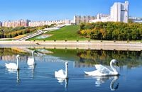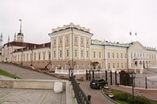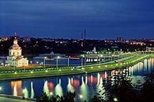
4 hours | Nouns of Chuvash language. Plural. Forms of ownership. Paired words. Relative words.  Questions in Chuvash language. Confirmation and negation.  Topics and dialogues «My family», «My address».
3 hours | Visit of the Chuvash National Museum: Address: 428032, Cheboksary, Red square, 5/2 tel.: (8352) 62-41-24
4 hours | Verbs of Chuvash language. Verb conjugation. Verbless sentences  Simple sentences. Word order.  Time. Year, month, days of week, day.  Topics and dialogues «My day».
3 hours | Visit to the Museum of the Civil War Hero V.I. Chapaev.Address: 428020, Cheboksary, Lenin st., 46А  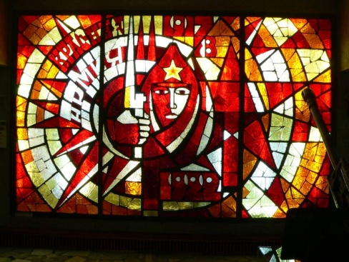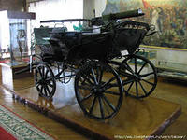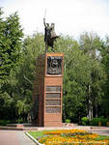
4 hours | Verb tenses. Present tense. Past tense. Future tense. Abstract verbs. Parts of body.  Topics and dialogues «Plans for tomorrow».
4 hours | Visit to the Centre of modern art.  Exhibitions of art painting, graphics, arts and crafts. Exhibition-sale of art objects. Walking tour to the Cheboksary Gulf.  Address: Cheboksary, Prezidentskiy boul. 1 tel.: 581877 site: www.artmuseum.ru  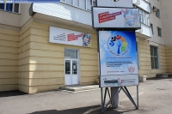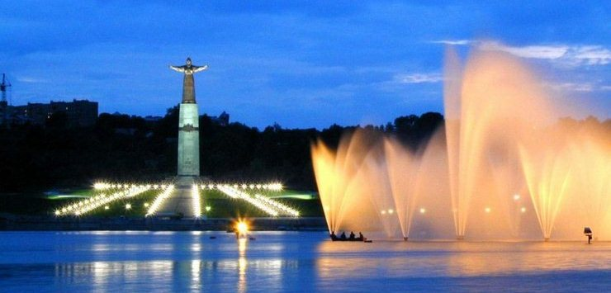
4 hours | Cases of Chuvash language. Declension of nouns and personal pronouns.  Topics and dialogues «Transport», «At the bus station»
5 hours | Trip to the Chuvash eco-village "Green Manor", which includes an eco-farm and a nursery of ornamental plants, an eco-hotel and a green restaurant, and zoo.  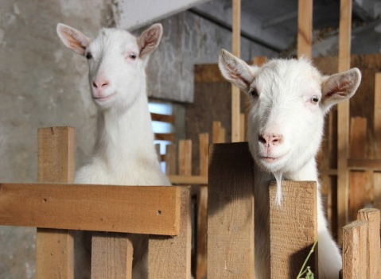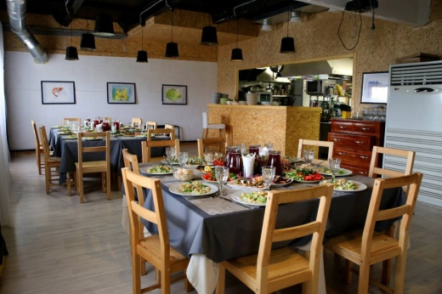
4 hours | Structure of Chuvash word. The concept of agglutinative and inflected languages. Derivation of verbs and nouns. Food. Vegetables and fruits. Professions.  Topics and dialogues «At the shop», «My favorite dish», «On a visit».
4 hours | Visit to the Art Picture Gallery, the Vvedensky Cathedral, the Assumption Cathedral, walk along the embankment of the Volga River.  Vvedensky Cathedral. The Cathedral in honor of the Entry into the Temple of the Blessed Virgin Mary, Cheboksary.  Address: Cheboksary, st. K. Ivanova, 21 tel: 581411 (administration) site: www.sobor-vvedenie.ru  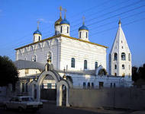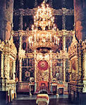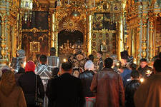  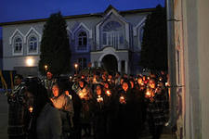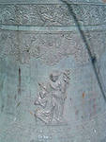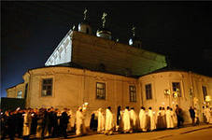
4 hours | Unconjugated forms of verb. Infinitive and verbal participle construction. The use of unconjugated verb forms in phrases and sentences.  Chuvash holidays  Topic and dialogue «My profession».
2 hours | 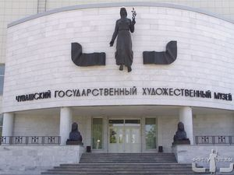  Visit to the Chuvash State Art Museum - the only museum in the world in the field of Chuvash art. Address: Cheboksary,  st. Kalinina, 60.
4 hours | Verb category. Imperative. Causative verbs. Subjunctive.  Topics and dialogues «Chuvash Republic», «Cheboksary – capital of Chuvash Republic», «Places of interest in Cheboksary».
4 hours | Visit to the ethnocultural park "Suvar" on the left bank of the Volga River (wooden pagan sculptures in a pine forest on the bank of the Volga River in the territory of the sanatorium "Chuvashia", beach, swimming).
4 hours | Tools of speech. Unions. Particles. Postpositions.  Verbs of motion. Verbs, denoting the beginning and the end of the action.  Onomatopoeic word in the Chuvash language  Topic and dialogue «My dream».
4 hours | 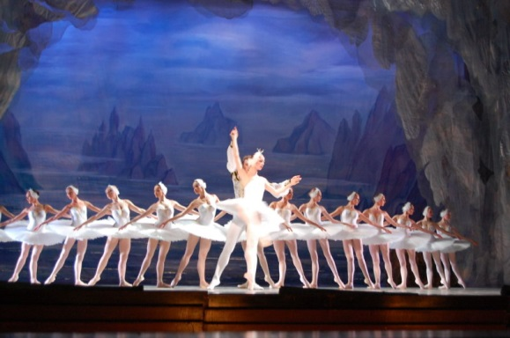  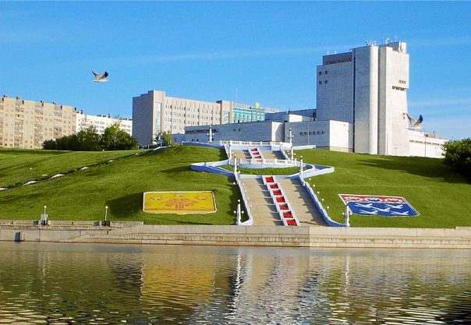  Visit to the Chuvash opera and ballet theatre.
4 hours | Complex sentences. Offers direct speech. Intonation and punctuation clearance clauses in the complex sentence.  Researchers of Chuvash language. State symbols of the Chuvash Republic. Prominent figures of art and literature in Chuvashia.  Direct speech.
4 hours | Visit to the Memorial Museum of the Cosmonaut A.G. Nikolaev.  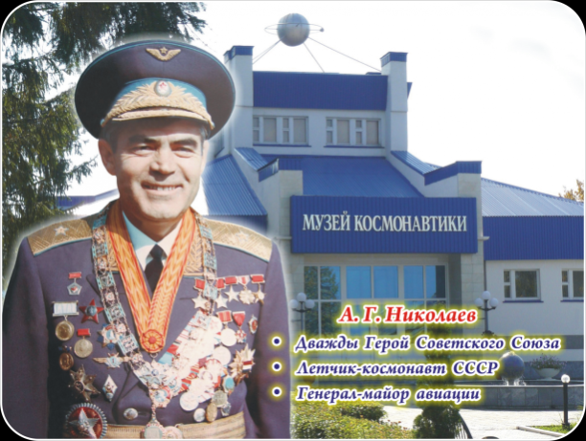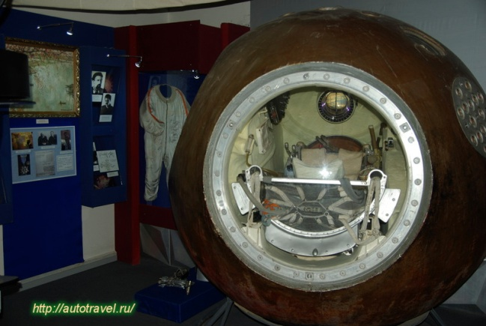
4 hours | Repetition.  Familiarity with samples of written text (the invitation, congratulation, ad). Reading excerpts from the poem "Narspi" K.V. Ivanov and "Spiritual Testament to Chuvash people" I.J. Yakovlev.
3 hours | 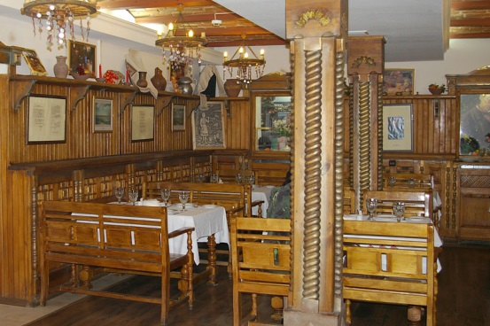  Farewell dinner in the cafe of the Chuvash national cuisine
 | Presentation of the certificates to the participants. Departure.

